2017

OBJECT-ORIENTED ANALYSIS AND DESIGN MODEL OF MOVIE/GAME DVD RENTAL SYSTEM

**yemisi Adeoluwa 30/11/2017**

|  |  |
| --- | --- |
| TABLE OF CONTENT | PAGE |
| MOVIE/GAME DVD USE CASE DIAGRAM | 2 |
| MOVIE/GAME DVD USE CASE DESCRIPTION STRUCTURED ENGLISH | 3-4 |
| MOVIE/GAME DVD CLASS DIAGRAM | 5 |
| RENT DVD SEQUENCE DIAGRAM | 6 |

**MOVIE/GAME** **DVD** **USE CASE DIAGRAM**

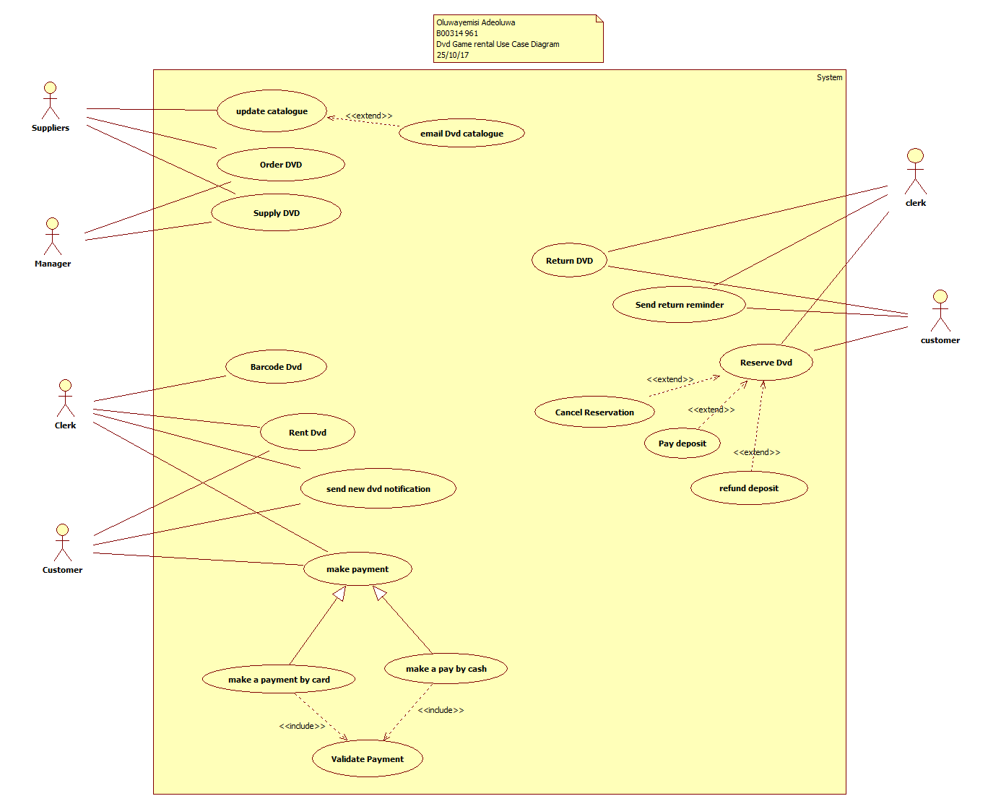

**STRUCTURED ENGLISH FOR RENT DVD IN THE MOVIE/GAME DVD RENTAL SYSTEM**.

**SCENARIO OF USE CASE RENT DVD**

Clerk click on Rental button

start the DVD rental function

create new rental form

Clerk enter customer’s details

Clerk scans DVD

repeat

scan DVD one by one secondly

record the DVD details

validate scanned DVD

until (there is no more DVD to be scanned)

compute the total amount of DVD

display the total amount of DVD to Clerk

**SCENARIO OF USE CASE MAKE PAYMENT**

Customer decides to pay by credit card ***(also inherits scenario pay by credit card)***

If payment is credit card

then system records credit card details

use recorded credit card details for upcoming payments

else reject payment

end if

record staff number to rental record

**Validate payment** ***(refers to use case Validate payment)***

System validate the credit card payment

If payment is valid

Click Complete

then repeat

change the status value of each rented copy to “out” one by one

until (there is no more rented copy)

end the rental process

else reject rent

end if

display “the rental has completed”

show “next click”

**MOVIE/GAME DVD CLASS DIAGRAM**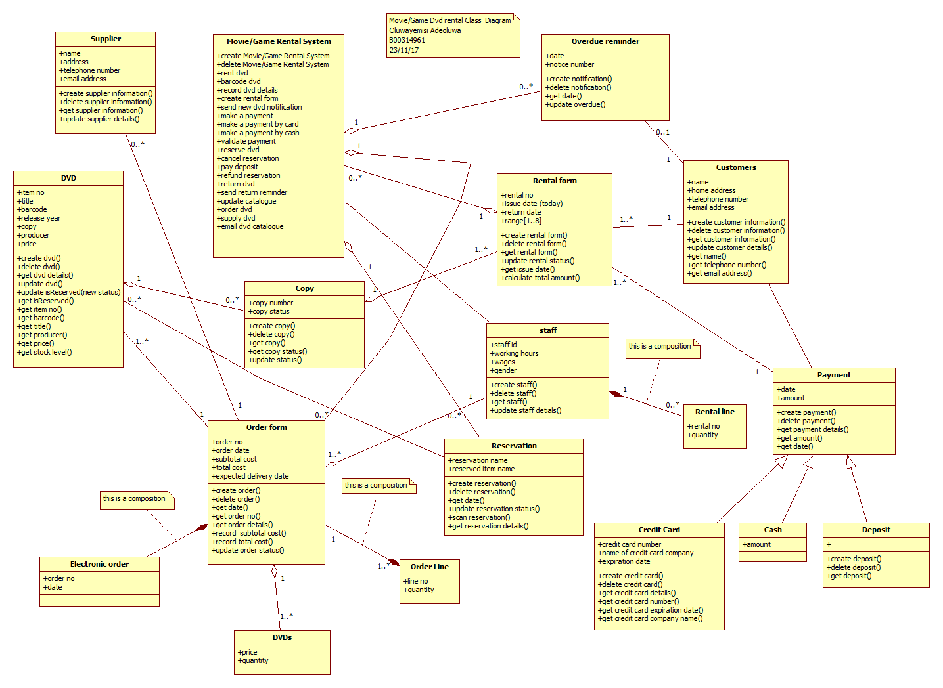

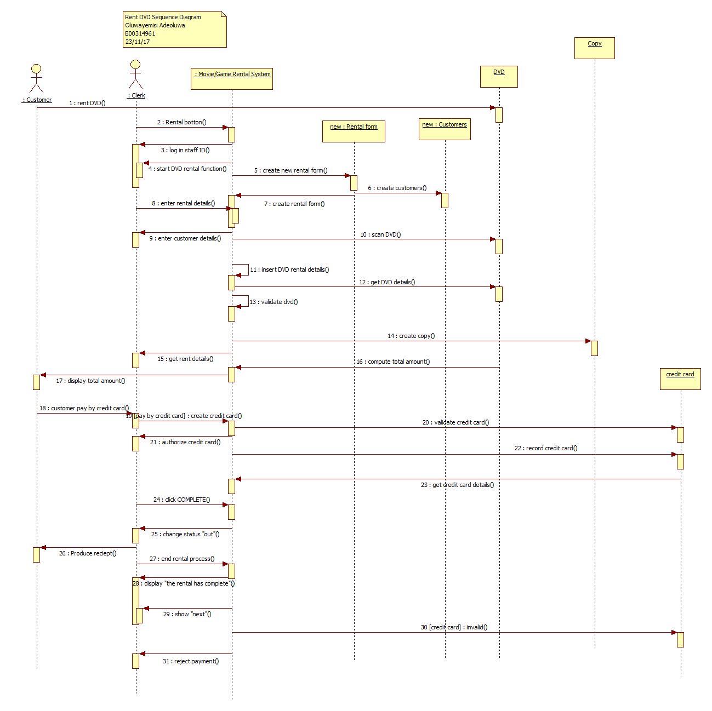**RENT DVD SEQUENCE DIAGRAM**